RCTC Athletic Training
Instructions for Completing Medical Paperwork

All athletes at RCTC are required to complete a medical physical, Insurance and Emergency form, and online portal each year. Failure to complete these forms prior to arriving on campus will result in the student athlete not being released to practice, play, or workout with the team.

To complete the online forms you will need access to the internet. You will also need your insurance card. All information entered will be stored on a secure server. If you have any questions during this process, you can email or call me at greg.holm@rctc.edu or (507)285-7577.

Below are detailed directions on how to login and complete the forms for Sports Medicine.

Open your web browser to the following address.
rctc.atsusers.com/athleteportal

Athletes new to RCTC should go to page 2

For returning athletes
Athlete ID (what you used last year)
Password – current personal password (not your password to login to computers at RCTC)

- Click Athlete Information
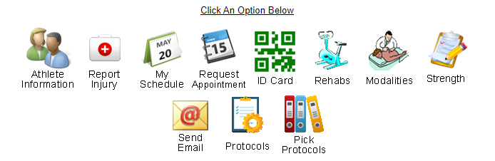
- You need to review and make updates to General, Insurance, and Contacts tabs. You must click save for system to register that it has been completed.
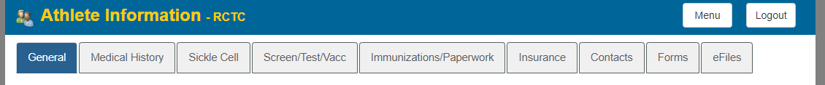
- In the Forms Tab you will find three (3) documents that need to be completed in this section. (There are 4 forms for football)
- Click on each form and then select New. Do not click on the signed forms from previous years.

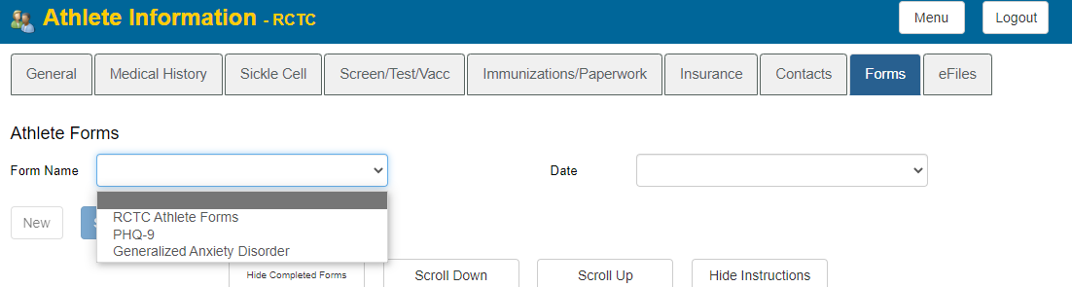

For new athletes
Stinger ID and Password are initially set as the word “new”. Once in to the system you will be able to create an original ID and Password.
Stinger ID – new
Password – new


new
You will need to allow cookies to continue with process.

You will complete the following four (4) tabs before saving. Do not click save until all four tabs are completed.
You do not need to complete the eFiles tab.

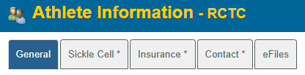

Select Organization – choose “RCTC” from dropdown menu.
Select Team 1 – choose the sport that you will be competing in at RCTC from the dropdown menu
- Complete all the highlighted boxes in yellow on the first page and your permanent and Rochester addresses if you know them.
- Enter Athlete ID –Create an ID that you can remember. You will use this to log into your medical records in the future.
- Create your password – You can choose any password that you will remember
- Year – Choose either Freshman or Sophomore.
- Text Address – is your 10 digit phone number followed by @ and the carrier domain. The carrier domain can be found by clicking on the button.
- Preferred Hospital Information
  - Rochester, MN has two hospitals please choose where you have medical coverage by your insurance
    - Mayo Clinic
    - Olmsted Medical Center
- Complete Medical Alerts – You can use the dropdown menu or type any medical alerts that you have in the yellow field. Type “None” if you have no alerts.
- If you have Allergies or Current Medications you can choose them from the dropdown menu.
- After completing the fist page move on to your insurance.

Click on Sickle Cell
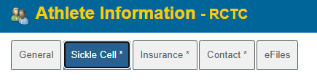
- Choose your Sickle Cell status from the dropdown menu.
- You do not need to have a Sickle Cell test completed. If you do not know your status please choose Unknown.
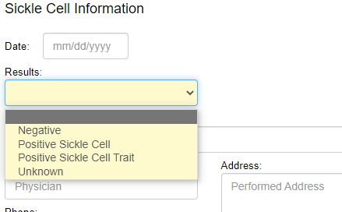
- Click Save

Click the Insurance tab
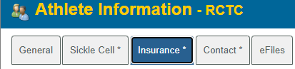
- Choose your insurance company from the drop down menu.
  - If your insurance company is not included in the dropdown list, you will need to click Add a New Insurance Company.
- Complete
  - Insurance type
  - Company phone number
  - ID#
  - Group #
  - Policy holder first and last name
  - Policy holder date of birth
  - Policy holders relationship to athlete
  - If your policy has a start and end date please include.
  - You are also able to upload a copy of your insurance card at this time

Click the Contact tab
- Input required emergency contact information

Click Save

***Once you have saved the information additional tabs will be created at the top of the page.
You will need to complete the Medical History and Forms Tabs

Click the Medical History Tab
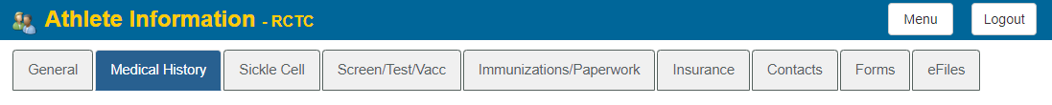
- Add any surgeries that you have had
- Click Save

Skip Screen/Test/Vacc, Immunizations/Paperwork, MH Forms, & eFiles

Click on Athlete Forms
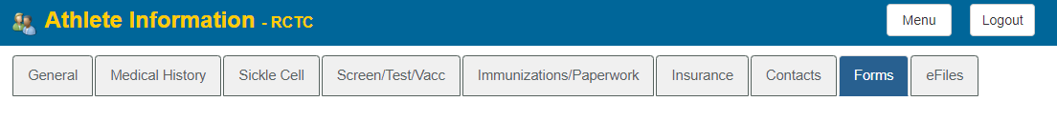
There are three (3) that need to be completed in this section. (There are 4 forms for football)

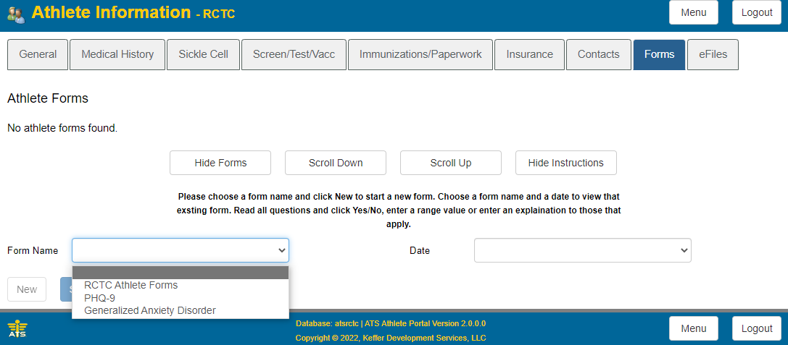
- Choose the form you wish to complete from the drop down menu.
- Select New
- Complete form
- The “RCTC Athlete Forms” has a button to click after each sections stating that you read and understand the information.
- Click to “Agree to using electronic signature”
- Type your name in the Signed By section
- Click Sign
- Click Save
- Repeat for remaining forms.

eFiles
Under this tab you will find two forms that can be printed and completed;
- NJCAA Preparticipation Form (Physical Form)
- Insurance and Emergency Information Form.
Both forms can also be found on the RCTC website. (http://www.rctcyellowjackets.com/information/participation)
- Please print the preparticipation form and bring with you to your Preparticipation exam or physical.
- The Insurance and Emergency Information Form must be completed and signed by a parent or guardian.
- Please return all pages of the preparticipation exam to the Athletic Training Staff by July 1.
  - Completed forms can either be mailed or scanned and emailed to greg.holm@rctc.edu, or uploaded in the eFiles tab.

Greg Holm
Head Athletic Trainer
Rochester Community and Technical College
Box 31
851 30th Ave SE
Rochester, MN 55904

